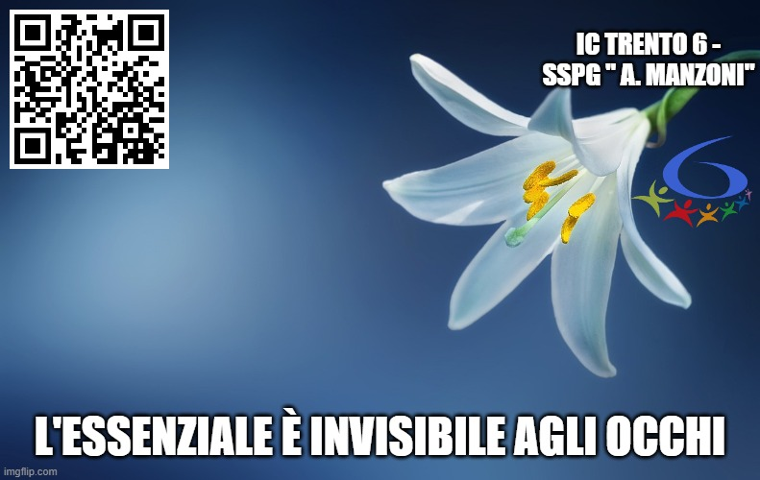 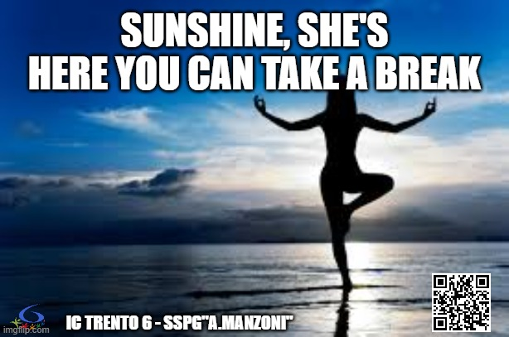

 

 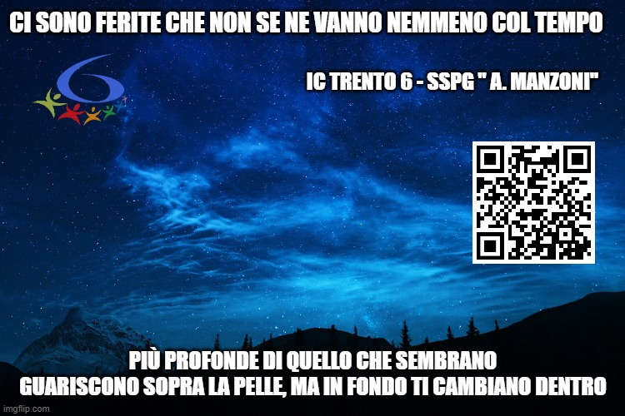

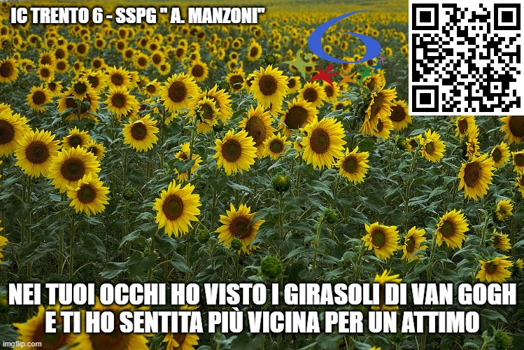 

|  |  |
| --- | --- |
| C:\Users\pr31999\Desktop\stampe\nassaraoiu_warnakula_2.jpg | C:\Users\pr31999\AppData\Local\Packages\Microsoft.Windows.Photos_8wekyb3d8bbwe\TempState\ShareServiceTempFolder\delprete.jpeg |
| C:\Users\pr31999\Desktop\stampe\russo.jpg |